May 13, 2017 - 12 Noon EDT
Feast Day of Our Lady of Fatima
100th Anniversary of the 1st of 6 Apparitions

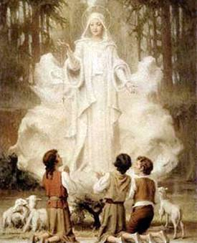
Abba Father,
In the Name of Jesus,
in the Unity, Power and Love of the Holy Spirit,
Under the Mantle of the Blessed Virgin Mary,
with All the Angels and Saints,
through the intercession
of the little daughter of the Divine Will,
Luisa Piccarreta,
Please Accept this Solemn Act
of Reparation and Consecration
of Russia, the United States and All Nations,
with All peoples, past, present and future,
as we Honor the 100th Anniversary
of Our Lady of Fatima.
On behalf of all mankind we beg You,
Come Holy Spirit!
May this Consecration hasten the
Triumph of the Immaculate Heart of Mary
and the Eucharistic Reign of the Sacred Heart of Jesus.
May the Coming of the Kingdom,
and of the Fulfillment of the prayer to You,
Our Heavenly Father,
“May Your Will be done on earth as it is in Heaven”
be accomplished and completed
in Your Most Holy Divine Will.
WE BELIEVE, WE RECEIVE!
Fiat! Amen!

